Codes:

import pandas as pd

import numpy as np

import matplotlib.pyplot as plt

%matplotlib inline

import seaborn as sns

import time

from sklearn.metrics import classification_report

from sklearn.metrics import confusion_matrix

from nltk.tokenize import RegexpTokenizer

from nltk.stem.snowball import SnowballStemmer

from sklearn.feature_extraction.text import CountVectorizer

from sklearn.metrics import accuracy_score

import joblib

# Loading the dataset

df= pd.read_csv("dataset_phishing.csv")

df.head()

df.describe()

df.shape

df.isnull().sum()

plt.figure(figsize=(5, 5)) # Adjust the figure size if needed

status_counts = df['status'].value_counts()

colors = ['skyblue', 'lightcoral']

explode = (0.5, 0)

plt.pie(status_counts, labels=status_counts.index, autopct='%1.1f%%', startangle=90, wedgeprops=dict(width=0.4), explode=explode, colors=colors)

plt.title("Distribution of Status")

# Add legend

plt.legend(status_counts.index, loc="best")

plt.show()

# checking unique values and counts from the collected object features

df['status'].value_counts()

tokenizer = RegexpTokenizer(r'[A-Za-z]+')

tokenizer.tokenize(df.url[0]) # this will fetch all the words from the first URL

# Tokenizing all the rows

print('Getting words tokenized ...')

t0= time.perf_counter()

df['text_tokenized'] = df.url.map(lambda t: tokenizer.tokenize(t))

t1 = time.perf_counter() - t0

print('Time taken',t1 ,'sec')

stemmer = SnowballStemmer("english") # choose a language

# Getting all the stemmed words

print('Getting words stemmed ...')

t0= time.perf_counter()

df['text_stemmed'] = df['text_tokenized'].map(lambda l: [stemmer.stem(word) for word in l])

t1= time.perf_counter() - t0

print('Time taken',t1 ,'sec')

# Joining all the stemmmed words.

print('Get joiningwords ...')

t0= time.perf_counter()

df['text_sent'] = df['text_stemmed'].map(lambda l: ' '.join(l))

t1= time.perf_counter() - t0

print('Time taken',t1 ,'sec')

cv = CountVectorizer()

feature = cv.fit_transform(df.text_sent) #transform all text which we tokenize and stemed

feature[:5].toarray() # convert sparse matrix into array to print transformed features

joblib.dump(cv, 'count_vectorizer.pkl')

trainX, testX, trainY, testY = train_test_split(feature, df.status)

from sklearn.ensemble import RandomForestClassifier

# Instantiate the RandomForestClassifier

rf_classifier = RandomForestClassifier()

# Fit the model to the training data

rf_classifier.fit(trainX, trainY)

# Make predictions on training and testing data

train_preds = rf_classifier.predict(trainX)

test_preds = rf_classifier.predict(testX)

train_accuracy = accuracy_score(trainY, train_preds)

test_accuracy = accuracy_score(testY, test_preds)

print("Training Accuracy:", train_accuracy)

print("Testing Accuracy:", test_accuracy)

# Generate confusion matrix and classification report

print("\nConfusion Matrix:")

print(confusion_matrix(testY, test_preds))

print("\nClassification Report:")

print(classification_report(testY, test_preds))

import joblib

# Save the trained model to a file

joblib.dump(rf_classifier, 'random_forest_model.pkl')

# Load the trained model

lr_model = joblib.load('random_forest_model.pkl')

# Function to preprocess the input URL

def preprocess_url(url):

tokenizer = RegexpTokenizer(r'[A-Za-z]+')

words_tokenized = tokenizer.tokenize(url)

stemmer = SnowballStemmer("english")

words_stemmed = [stemmer.stem(word) for word in words_tokenized]

return ' '.join(words_stemmed)

# Function to make predictions

def predict_url_status(url):

preprocessed_url = preprocess_url(url)

feature = cv.transform([preprocessed_url])

prediction = lr_model.predict(feature)[0]

return prediction

url_to_predict = "http://vamoaestudiarmedicina.blogspot.com/"

prediction_result = predict_url_status(url_to_predict)

if prediction_result == 'phishing':

print(f"The URL '{url_to_predict}' is predicted to be a phishing site.")

else:

print(f"The URL '{url_to_predict}' is predicted to be a legitimate site.")

from sklearn.preprocessing import LabelEncoder

# Convert status labels to numerical values

label_encoder = LabelEncoder()

df['status_encoded'] = label_encoder.fit_transform(df['status'])

# Split the dataset

trainX, testX, trainY, testY = train_test_split(feature, df['status_encoded'], test_size=0.2, random_state=42)

from sklearn.pipeline import Pipeline

from sklearn.neural_network import BernoulliRBM

from sklearn.linear_model import LogisticRegression

# Define the RBM model with 20 iterations

rbm = BernoulliRBM(n_iter=20, random_state=0, verbose=True)

# Define the Logistic Regression model

logistic = LogisticRegression(max_iter=10000)

# Create a pipeline combining RBM and Logistic Regression

dbn_classifier = Pipeline(steps=[('rbm', rbm), ('logistic', logistic)])

# Training the DBN model

print("Training Deep Belief Network...")

t0 = time.time()

dbn_classifier.fit(trainX, trainY)

print("Training time:", time.time() - t0)

# Evaluate the DBN model

print('Training Accuracy:', dbn_classifier.score(trainX.toarray(), trainY))

print('Testing Accuracy:', dbn_classifier.score(testX.toarray(), testY))

# Obtain accuracy score for DBN classifier

dbn_accuracy = dbn_classifier.score(testX, testY)

print("DBN Accuracy", dbn_accuracy)

from sklearn.metrics import confusion_matrix

# Predictions on the test set

predictions = dbn_classifier.predict(testX)

# Generate confusion matrix

conf_matrix = confusion_matrix(testY, predictions)

# Plot confusion matrix

plt.figure(figsize=(8, 6))

sns.heatmap(conf_matrix, annot=True, fmt='d', cmap="YlGnBu",

xticklabels=label_encoder.classes_,

yticklabels=label_encoder.classes_)

plt.xlabel('Predicted Label')

plt.ylabel('True Label')

plt.title('Confusion Matrix')

plt.show()

from sklearn.neural_network import BernoulliRBM

from sklearn.pipeline import Pipeline

from sklearn.preprocessing import StandardScaler

# Feature scaling

scaler = StandardScaler(with_mean=False)

scaled_trainX = scaler.fit_transform(trainX)

scaled_testX = scaler.transform(testX)

# Create RBM model

rbm = BernoulliRBM(n_components=256, learning_rate=0.01, random_state=0, verbose=True, n_iter=20)

# Create logistic regression model for classification

logistic_classifier = LogisticRegression()

# Create a pipeline to combine RBM and Logistic Regression

rbm_classifier = Pipeline(steps=[('rbm', rbm), ('logistic', logistic_classifier)])

# Training the model

rbm_classifier.fit(scaled_trainX, trainY)

# Testing the model

rbm_accuracy = rbm_classifier.score(scaled_testX, testY)

Scores_ml['RBM'] = np.round(rbm_accuracy, 2)

print(f'RBM Testing Accuracy: {rbm_accuracy}')

# Classification Report and Confusion Matrix

print('\nCLASSIFICATION REPORT\n')

print(classification_report(rbm_classifier.predict(scaled_testX), testY, target_names=['Bad', 'Good']))

con_mat_rbm = pd.DataFrame(confusion_matrix(rbm_classifier.predict(scaled_testX), testY),

columns=['Predicted:Bad', 'Predicted:Good'],

index=['Actual:Bad', 'Actual:Good'])

print('\nCONFUSION MATRIX')

plt.figure(figsize=(6, 4))

sns.heatmap(con_mat_rbm, annot=True, fmt='d', cmap="YlGnBu")

# Define the models and their corresponding accuracy scores

models = ['Random Forest', 'DBN', 'RBM']

accuracy_scores = [test_accuracy, dbn_accuracy, rbm_accuracy]

# Check for missing or invalid accuracy scores

valid_accuracy_scores = [score if score is not None and not np.isnan(score) else 0 for score in accuracy_scores]

# Plotting the bar chart

plt.figure(figsize=(10, 6))

bars = plt.bar(models, valid_accuracy_scores, color=['skyblue', 'orange', 'lightgreen'])

# Add labels to the bars

for bar, score in zip(bars, valid_accuracy_scores):

plt.text(bar.get_x() + bar.get_width() / 2, bar.get_height() - 0.05, f'{score:.2f}', ha='center', color='black', fontsize=10)

plt.xlabel('Models')

plt.ylabel('Testing Accuracy')

plt.title('Comparison of Model Testing Accuracy')

plt.ylim(0, 1) # Set the y-axis limit from 0 to 1

plt.grid(axis='y', linestyle='--', alpha=0.7)

plt.show()

**Screenshots**

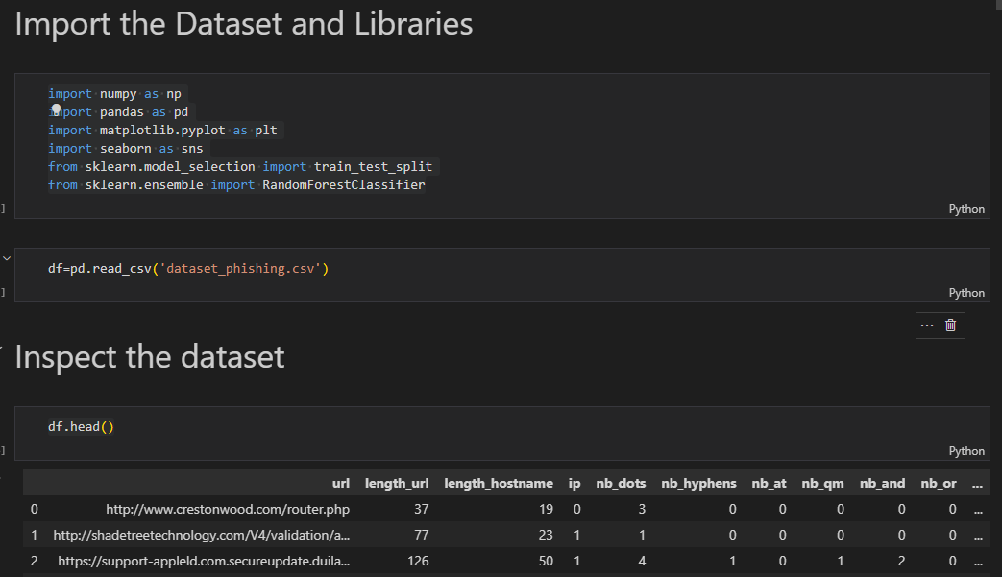

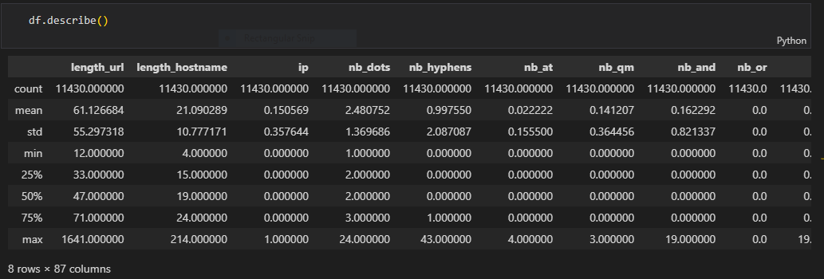

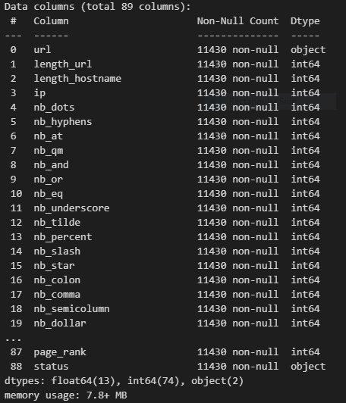

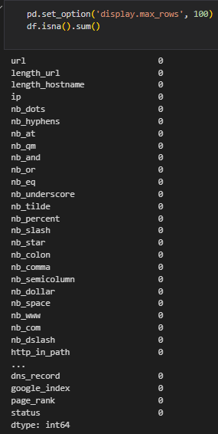

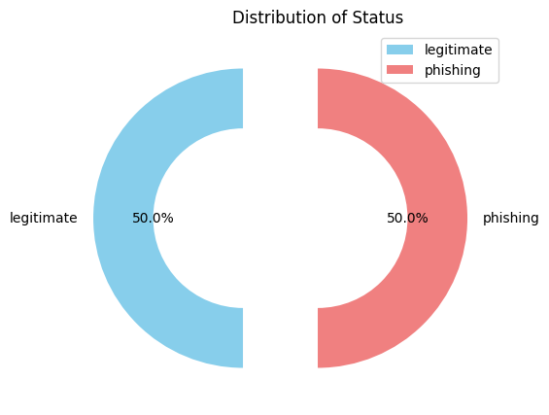

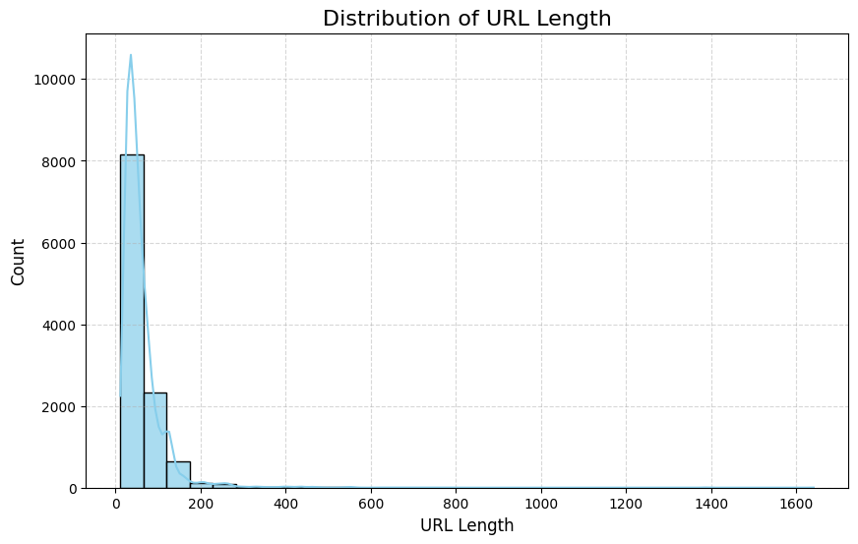

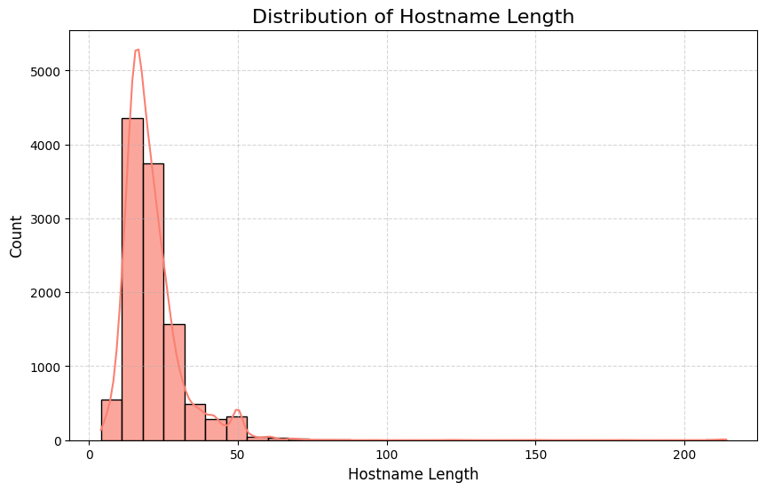

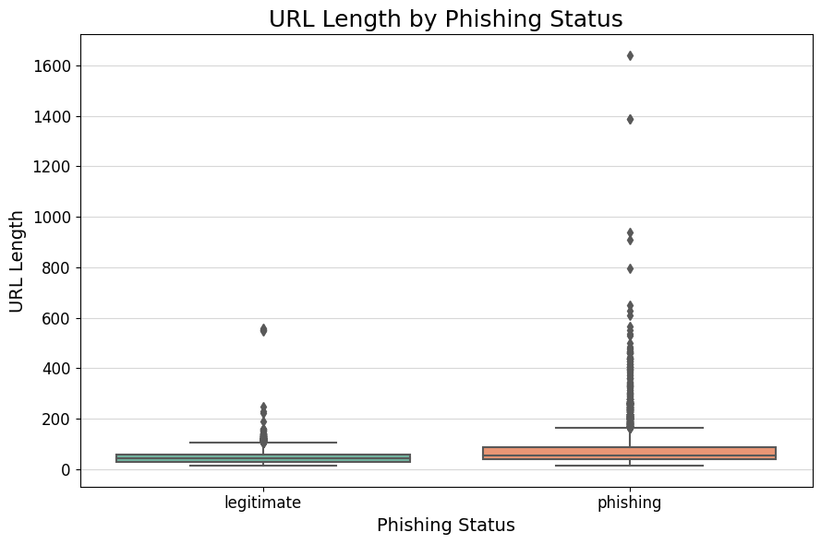

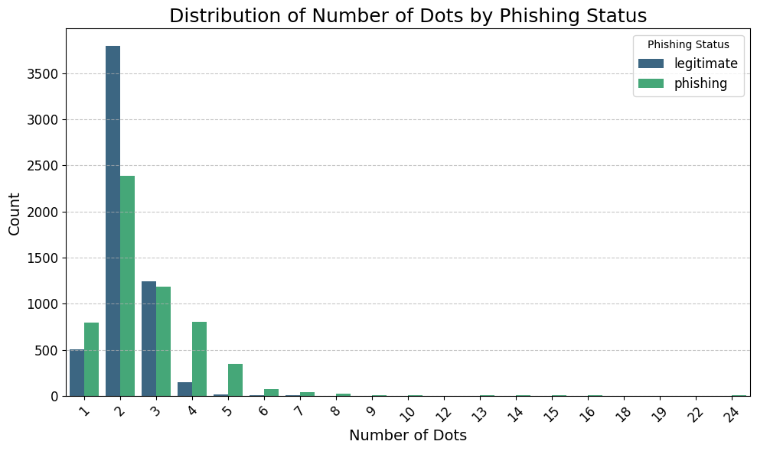

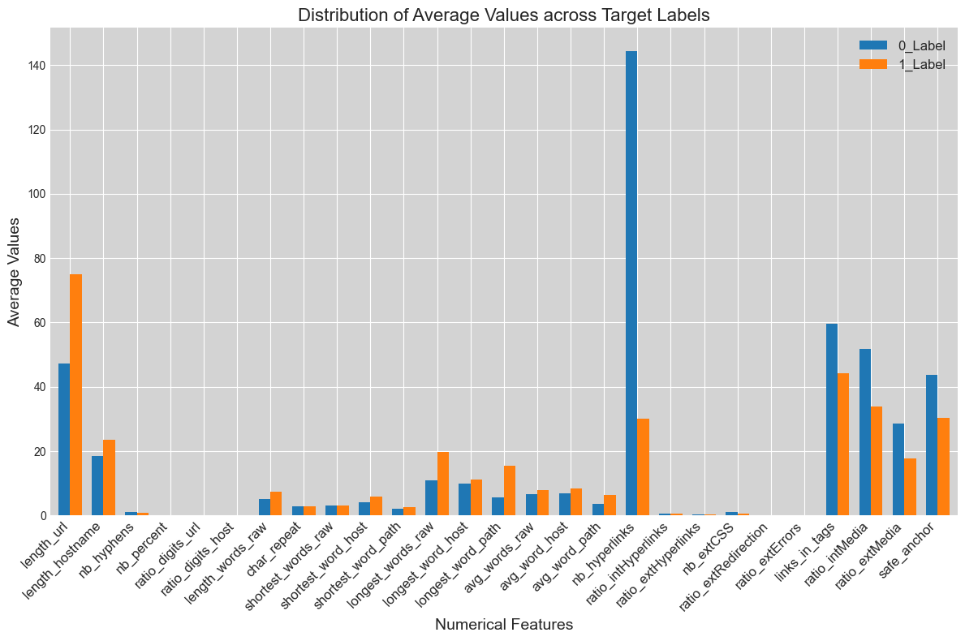

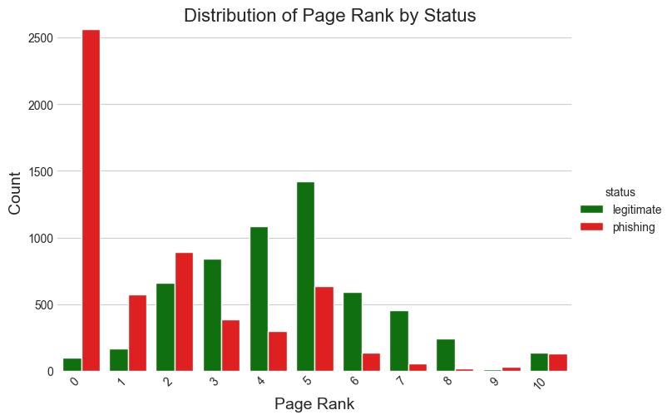

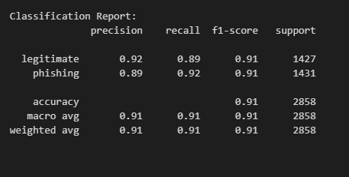

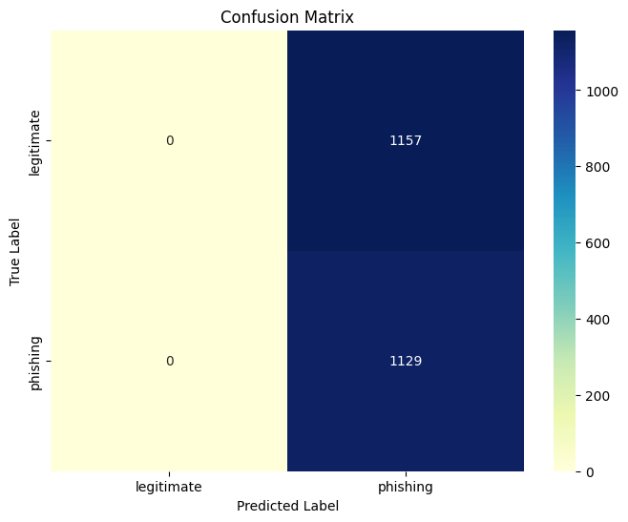

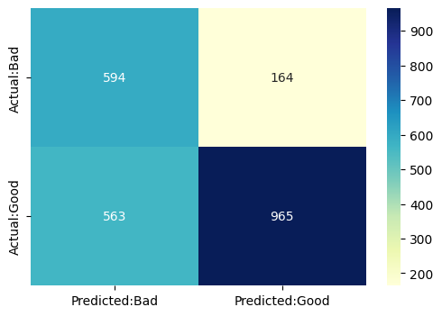

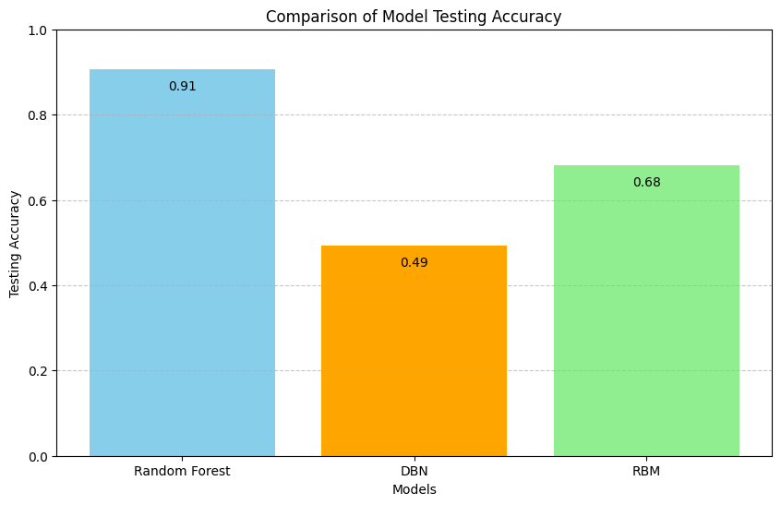

**Module 1: Data Exploration and Preprocessing**

This module focuses on loading and exploring the dataset, understanding its structure, and preprocessing steps. Key steps include:

Loading Data: Importing the dataset using pandas (pd.read_csv) and displaying the first few rows to understand the data structure.

Data Summary: Utilizing df.describe() and df.info() to obtain summary statistics and information about the dataset.

Handling Missing Values: Identifying and handling missing values using df.isna().sum().

Data Transformation: Transforming categorical values into numerical representation, e.g., converting 'status' labels into binary values.

**Module 2: Exploratory Data Analysis (EDA)**

EDA performing Exploratory Data Analysis to understand relationships and patterns within the dataset.

**Correlation Analysis**: Computing and visualizing the correlation matrix using sns.heatmap to identify relationships between features.

**Feature Selection**: Implementing a function (feature_selector_correlation) to select relevant features based on a correlation threshold.

**Module 3: Model Training and Evaluation**

Models covers training machine learning models (Random Forest Classifier, Logistic Regression, SVC, Decision Tree) and evaluating their performance:

**Data Splitting**: Splitting the dataset into training and testing sets using train_test_split.

**Model Training**: Utilizing scikit-learn to train Random Forest (96), Logistic Regression(84), Support Vector Classifier (SVC) (70), and Decision Tree (93) models.

**Model Evaluation**: Creating a custom function (custom_accuracy_set) to evaluate the models on training and testing sets, including confusion matrix and classification report.

**Module 4: Model Comparison and Visualization**

**Model Comparison**: Using bar charts to compare training, testing, and cross-validation accuracies for each model.

**Visualization**: Visualizing feature importances using a bar chart for the Random Forest model.

**Module 5: Cross-Validation and Test Size Sensitivity**

**Test Size Sensitivity**: Examining how varying test sizes (e.g., 20%, 30%, 40%, 50%) affects model accuracy.

**Cross-Validation Scores**: Calculating cross-validation scores for each model and presenting the results.